**Project Readme Documentation**

**# Project Title**

DunkDiggers - UMD Basketball

**#** **Project Purpose**

DunkDiggers team implemented a robust relational database model for UMD basketball statistics capturing relationships between players, matches and performance statistics. Our objective is to provide a user-friendly platform to team managers, players and support staff to help in their informed decision-making, strategic planning, and effective game preparedness for upcoming matches.

**# Data Source**

DunkDiggers team utilizes data from the UMD Terps Basketball Stats data as present over: [*https://umterps.com/sports/mens-basketball/stats/2023-24*](https://umterps.com/sports/mens-basketball/stats/2023-24)

**# References**

*From the UMD Terps Basketball site - Stats for season 2023-24*

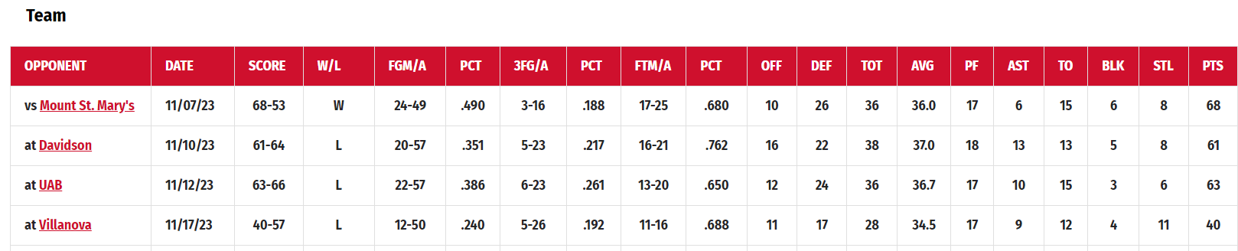

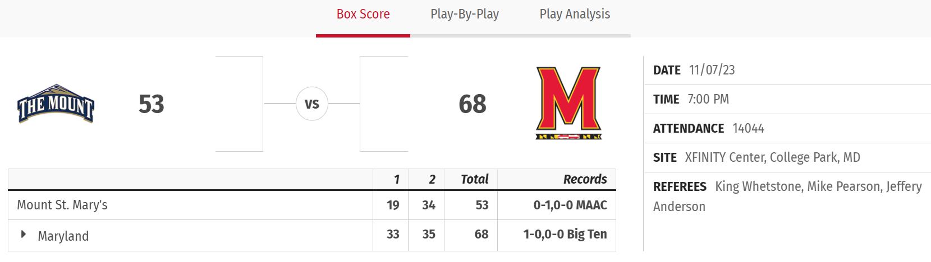

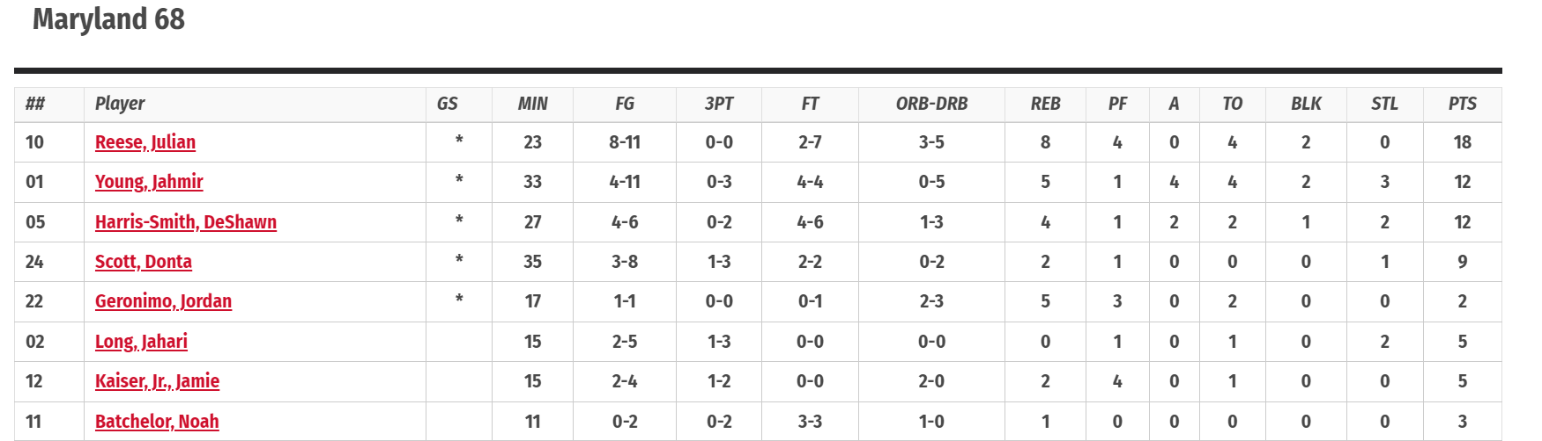

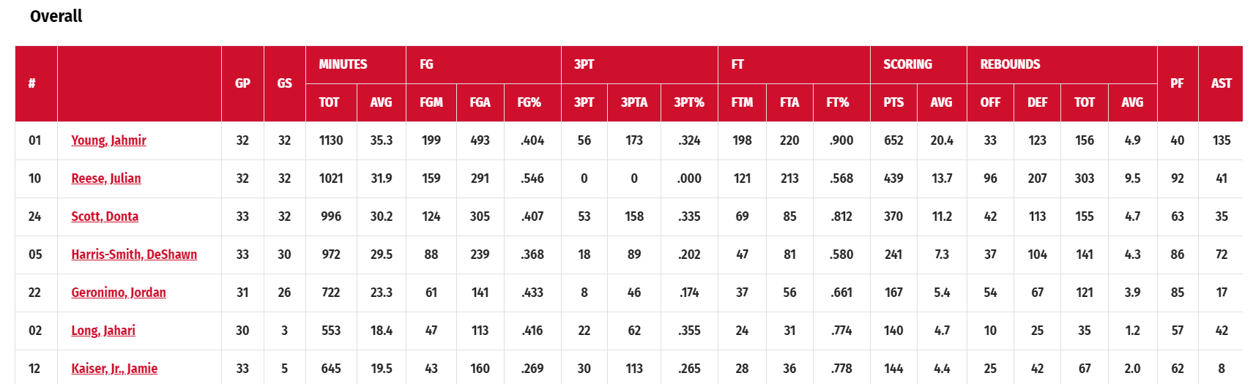

**# Prerequisite**

To have any platform like SQL Management Studio supporting SQL queries.

**# Guidelines**

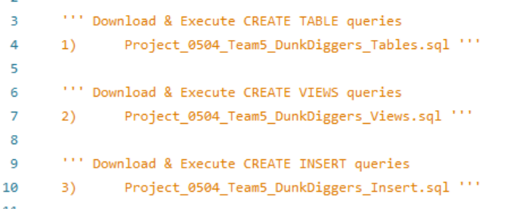

**Tables Creation**

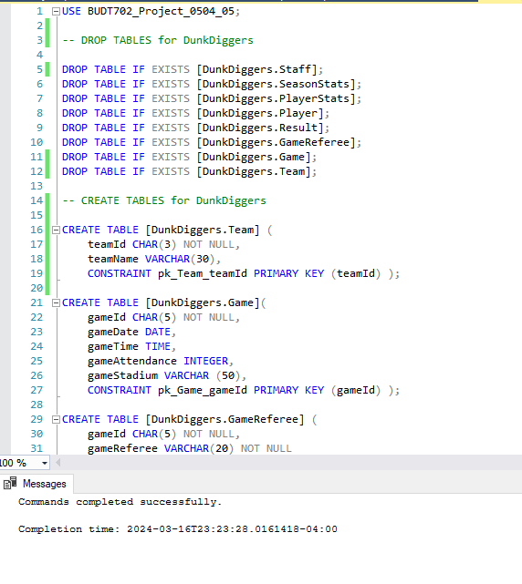

**Views Creation**

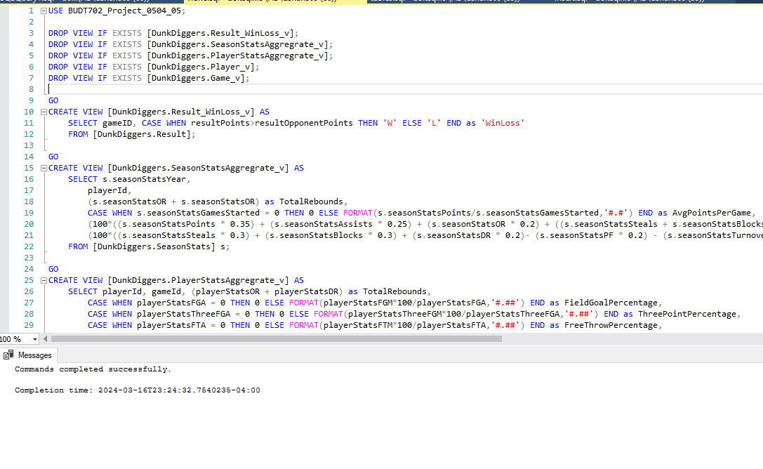

**INSERT TABLE queries**

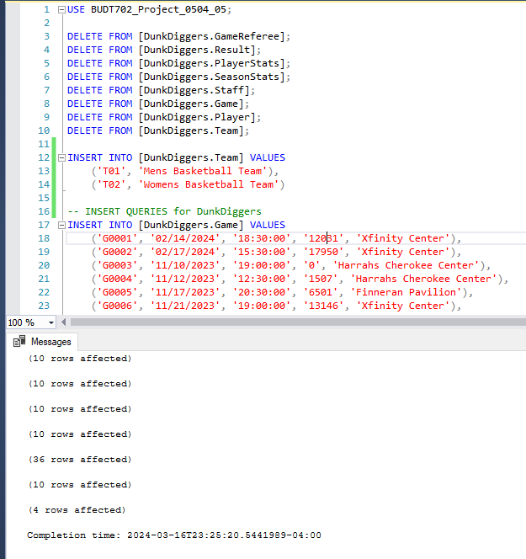

This will help users to create all the UMD basketball tables including Player, Game, Seasonstats details, etc., along with the data insertion for further analysis use. This will help the database establish relationships between the participating entities through relevant primary and foreign keys.

**# Database brief description**

Entities/Actors - Game, Team, Result, Player, PlayerStats, SeasonStats, Staff

Brief description of each table :

**Game** table has details of games like on which date and time the game was played. It also includes which stadium hosted the game and what was the viewers attendance for the same. The name of the referees officiating the game is also captured.

**Team** table contains details of which UMD basketball team like the Men's Basketball team or Women's Basketball team we capture the stats.

**Result** table records the opponent's name and the points scored by both teams in the match. Additionally, it includes Win/Loss statistics based on the points accumulated by the two competing teams.

**Player** table holds all the demographic information of the UMD basketball players like Jersey Number, Name, Height, Weight, etc. and which basketball team the player is part of.

**PlayerStats** records the performance metrics of individual players for a specific match, including the duration they spent on the field, the number of attempts made by the player, the successful conversions into baskets, the accuracy of three-point scoring, as well as other offensive and defensive statistics.

**SeasonStats** tracks the aggregated performance of a player throughout the season, encompassing the player's participation in games, total minutes played, conversion metrics for attempts and successful points scored, along with additional offensive and defensive statistics spanning the entirety of the season.

**Staff** table includes details like name and position/role about supporting staff like Team head coach, Team Physio, Team Manager, etc. for the UMD basketball teams.

**# Project features**

Set queries have been prepared in the ‘DML.sql’ file to help users fetch the insights for achieving mission objectives. The following details will explain how each query will help in doing so:

Execute the required query present in DML for the objective you are interested for:

**1)****What are the Offensive Statistics for the Top 5 Offensive Players?**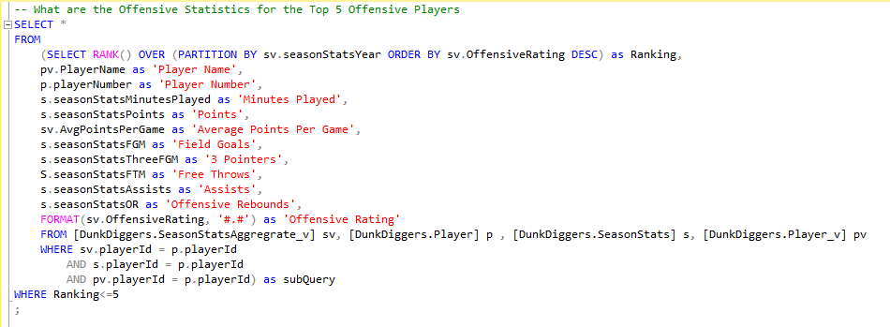

**2)** **What are the Defensive Stats for the top 5 Defensive Players?**

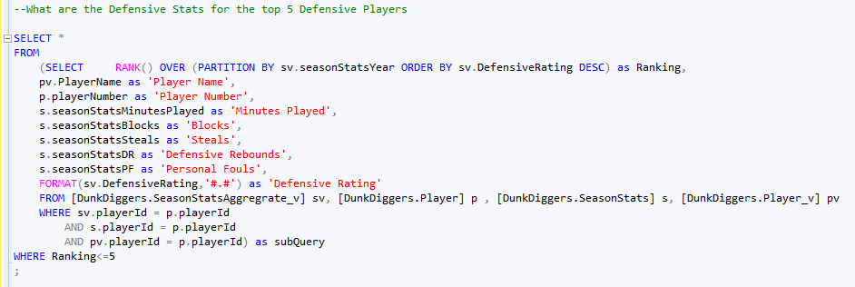

The above two queries help in providing insights into evaluating top offensive and defensive players based on their recent statistics. This helps in ensuring the best lineup with balance between offense and defense to maximize the team's chances of success thereby fulfilling the mission objective of team selection and evaluation of player performance across the season.

**3) What are the team Statistics in Wins compared to Losses?**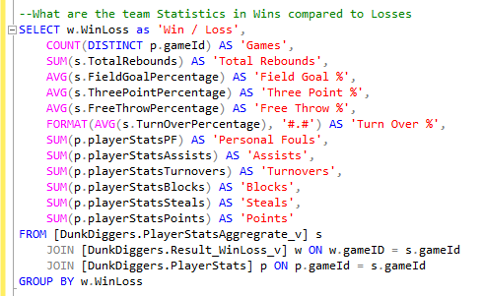

The above query presents a comparison for various aggregated team statistics in wins and losses to compare the various areas of the game and how the team is faring based on the result. This allows us to understand the strategy by identifying the team's strengths and weaknesses, areas to improve or focus on during the games. This also helps us in managing the team’s training.

**4)** **What are the player statistics comparison vs different opponents and overall stats of the player and the team?**

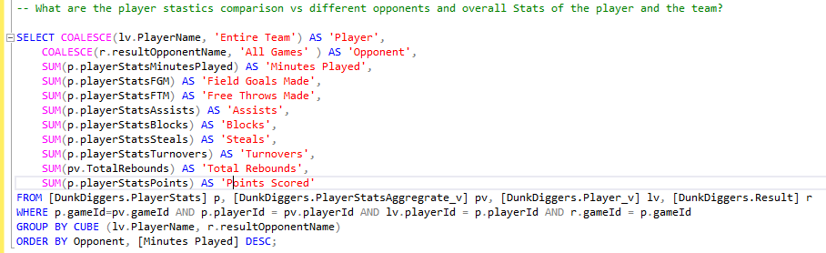

The above query helps us compare the players and their performance in various games. It allows us to form strategies based on player form, team form and opponents hence optimizing the gameplay. It also allows us to manage the individual areas of practices for the different players.

**# Contact Us**

Feel free to contact the DunkDiggers team for any queries, concerns, or further clarification regarding the project. We are here to assist you with any issues you may encounter or to provide additional insights as needed :

Raunak Singh - [raunak@umd.edu](mailto:raunak@umd.edu)

Dhruvin Shah - [dshah309@umd.edu](mailto:dshah309@umd.edu)

Nilay Somani - [nsomani@umd.edu](mailto:nsomani@umd.edu)

Alex Nitzl - [anitzl@umd.edu](mailto:anitzl@umd.edu)